**Little-known lives: Rotumans in 19th-century Aotearoa New Zealand**

By: [Sean Mallon](https://blog.tepapa.govt.nz/author/seanjmallon/)

**To mark the recent Rotuman Language Week 2021, Senior Curator Pacific Histories and Cultures Sean Mallon shares two rare stories of Rotuman travellers who found their way to New Zealand in the early 1800s, and how a contemporary Rotuman artist has remembered one of them.**

In the late 1700s, five or six hundred years after the ancestors of Māori settled Aotearoa New Zealand, other waves of people began arriving here. Most were Europeans, but from the late 1700s, a trickle of Pacific people also came on European ships.

Initially, they came as whalers, traders and adventurers. By the mid-1800s, they arrived as missionary students, as members of political delegations, and as explorers driven by curiosity.

Some stayed only briefly. Others settled permanently. Often, little is known about many of them, apart from brief and rare mentions in diaries, newspapers, and other records.

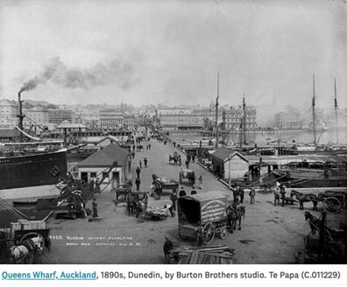

**The mystery of John Newa**

The first story comes from the newspapers and a coroner’s report into the mysterious death of a Rotuman named John Newa in May 1868.

He had come to Auckland on the cutter *Ringdore*, and although he was only 16 years old, the collector of customs had clearly considered Newa trustworthy enough to give him charge of the *Ringdore* and another cutter while they were under seizure by customs officials.

He went missing, however, and his body, with no apparent injuries, was found floating in the harbour several days after he disappeared. Newa was identified by Thomas Murphy, who recognised his friend by his hand, which had been disfigured by a fall from a tree. He described him as an expert swimmer.

The inquest reported that Newa was “Found drowned without any marks of violence”.

**Glimpses of Saturday**

Another Rotuman who appears briefly in the records is Saturday. I assume this wasn’t his real name, but one given to him by people who couldn’t pronounce his Rotuman name.

He is mentioned briefly in the writings of Edward Jerningham Wakefield, a member of a prominent colonist family from England, who travelled through New Zealand in the 1840s.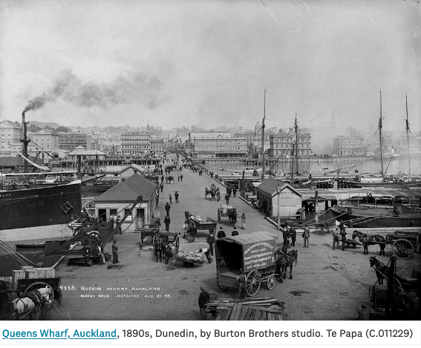

Saturday was originally working for Richard (Dicky) Barrett, a whaler who worked the Cook Strait, but he joined Wakefield’s party to cater and officiate ‘as Jack of-all-trades’.

He appears in little vignettes in the main narrative of *Adventure in New Zealand*, Wakefield’s account of his travels; a few brief sentences portray a man appreciated and admired, but who remained very much on the periphery of the story.

In a moment away from the exertions of journeying and plagued by insects, Wakefield writes, ‘Even the natives had exclaimed against the numbers and perseverance of the nae-nae, as the mosquitoes are called in Maori. Saturday’s stolid unconcerned face was rich to behold, as he sat by the fire stirring them out of each ear with a small twig.’

This description tells us more than the only known painted image of Saturday. His likeness appears in a watercolour by artist and explorer Charles Heaphy depicting several men rowing a boat up the Wairoa River between banks ‘clothed with the finest kauri timber’.

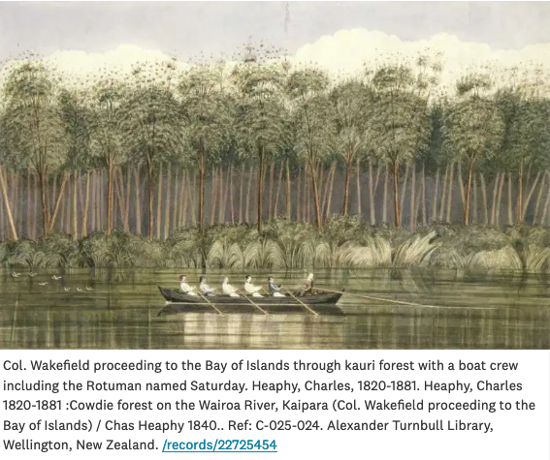

Seated in the stern is Colonel William Wakefield, Edward’s uncle, who had assembled a crew that included Saturday and a Māori man called Te Whare, who helped carry his baggage. The colonel is the only discernible figure and, regrettably, it is not clear which man is Saturday.

Of course, the people on the boat are less important than the artist’s depiction of the lucrative resources and rich landscape on the river’s banks.

Elsewhere, Wakefield describes how, a few days before the river trip, Saturday manoeuvred their boat in a display of confident seamanship that undoubtedly prevented a capsize. He writes: ‘Saturday…took the steer-oar, and steered us with great presence of mind through a threatening line of surf; when we found ourselves in a smooth channel, gliding towards the harbour at the rate of five knots.’

Again this is a fleeting moment, one that adds to the image of the expert Pacific Islander, capable on the sea – but ultimately an average day’s work for a Rotuman baggage handler and cook in nineteenth-century New Zealand.

**A garland for stories**

In 2007, we presented artist Sofia Tekela-Smith with the brief references to Saturday’s presence in Aotearoa, and she created a tēfui in memory of him. Tekela-Smith says:

*The tēfui is a scented garland given to Rotumans when they depart on a journey. The scent lingers for a long time, and I imagine that Saturday would have carried one to remind him of his homeland and loved ones.*

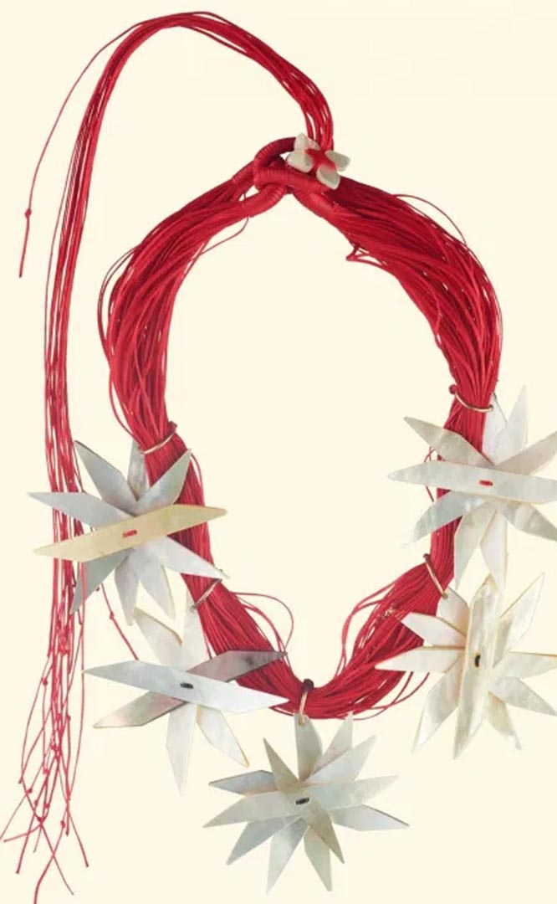

Tēfui, made by Sofia Tekela-Smith, New Zealand (Rotuma, Uvea, Futuna, Scotland). Made from mother-of-pearl shell, sterling silver, gold, and waxed thread, 2007. Te Papa

## References:

* [Coroner, Auckland. Inquest proceedings on John Newa](https://www.archway.archives.govt.nz/ViewFullItem.do?code=24269699) (R24269699) J1 76 1876/1705. 22 May 1868 Archives New Zealand, Wellington Office
* [Coroner’s inquest—death from drowning](https://paperspast.natlib.govt.nz/newspapers/NZH18680516.2.2). New Zealand Herald, Volume V, Issue 1403, 16 May 1868, Page 4
* Mallon, S. (2012) Little Known Lives: Pacific Islanders in 19th century New Zealand in Mallon, S. Mahina-Tuai, Kolokesa and Salesa, Damon (eds) (2012) Tangata o le Moana: New Zealand and the people of the Pacific. Te Papa Press, Wellington.
* Wakefield, E.J. (1908) Adventure in New Zealand from 1839 to 1844; with some account of the beginning of the British colonization of the islands, Robert Stout (ed.), Whitcombe and Tombs, Wellington, Christchurch and Dunedin, 1908, pp. 109, 151.